Zoom University Math 54 Worksheet 2

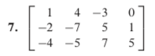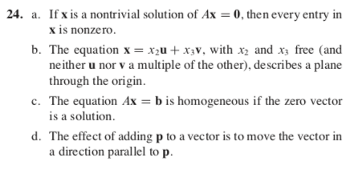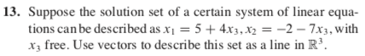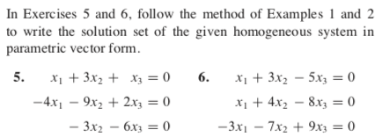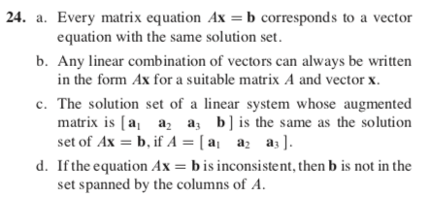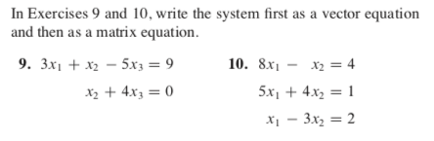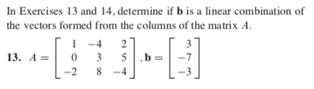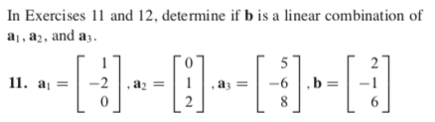

Section 1.4

Section 1.3

Section 1.7

Section 1.5